Process By Which a Local Senschal Approves an Event

When someone (generally an event Autocrat) attempts to post an event on the East Kingdom Calendar, we at the webministry have no way to know if the event they are posting is in any way real. Therefore, each event posting must be approved by someone who can make that determination.
When the event is first posted, an email is automatically generated to the Seneschal of the branch hosting the event. This email is sent to seneschal@<branch>.eastkingdom.org and copies are also sent to the Kingdom Webminister and the Kingdom Calendar Deputy Webminister. Here’s an example below:
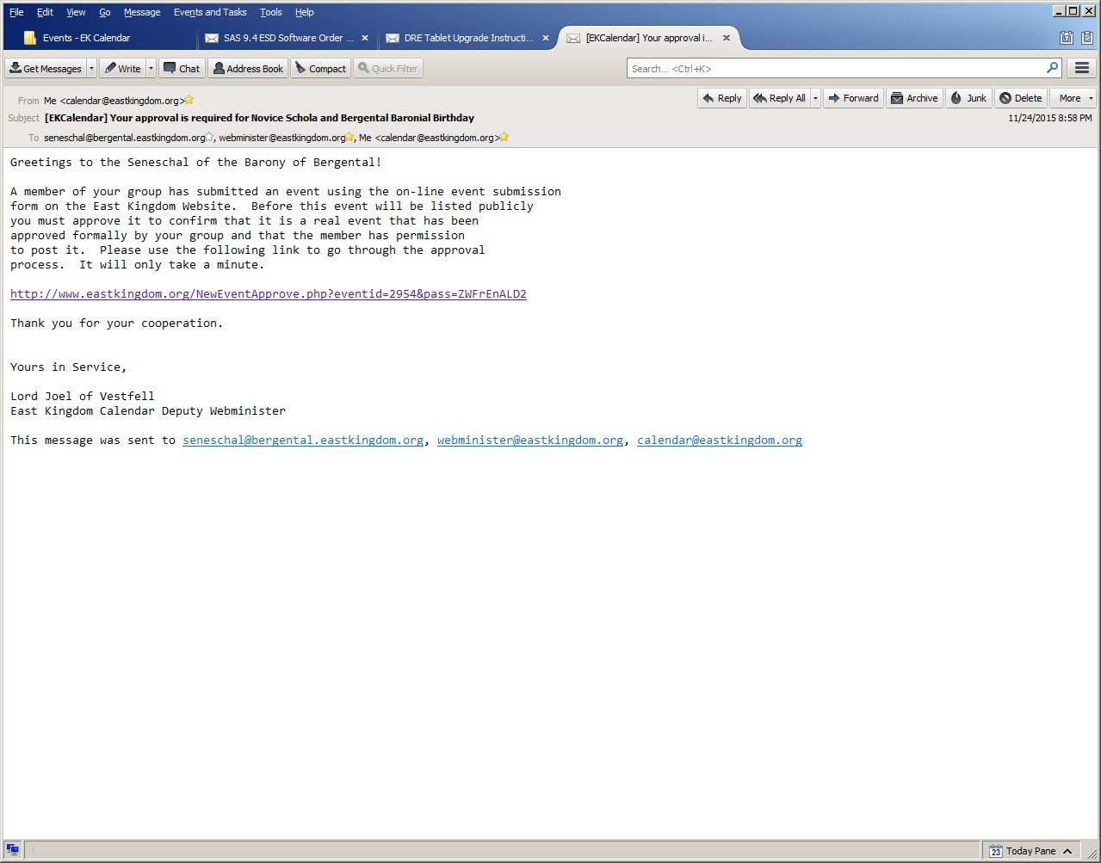

By clicking on the link that begins http://www.eastkingdom.org/NewEventApprove.php you are taken to the event posting as it will appear once it is approved, with one important difference: at the bottom is an “Approved” button:
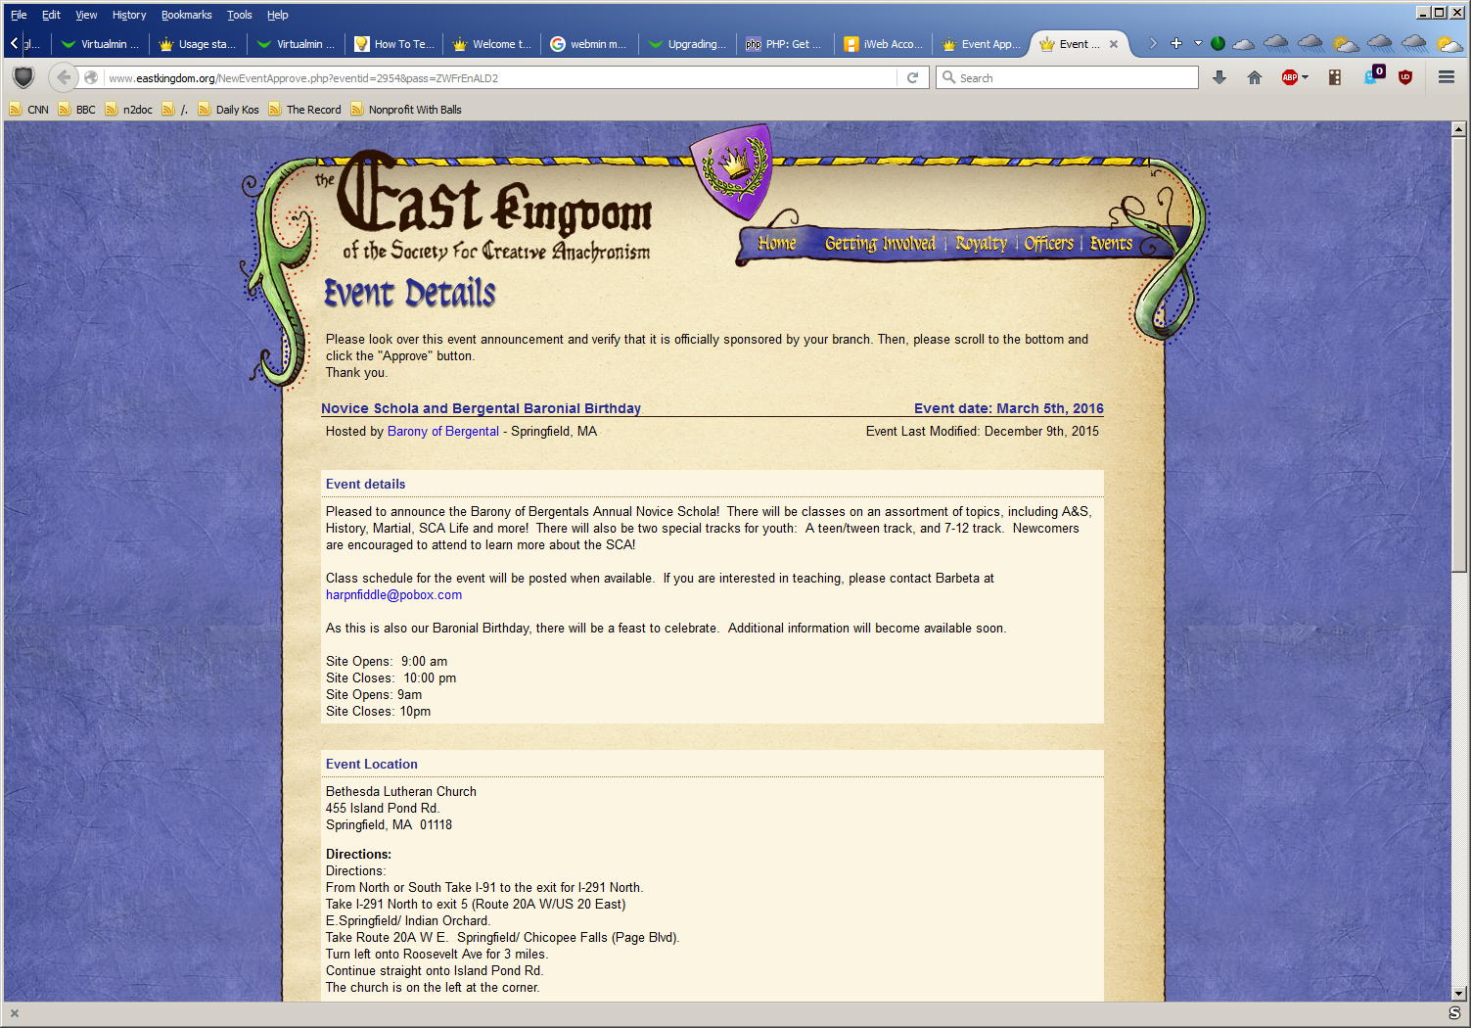
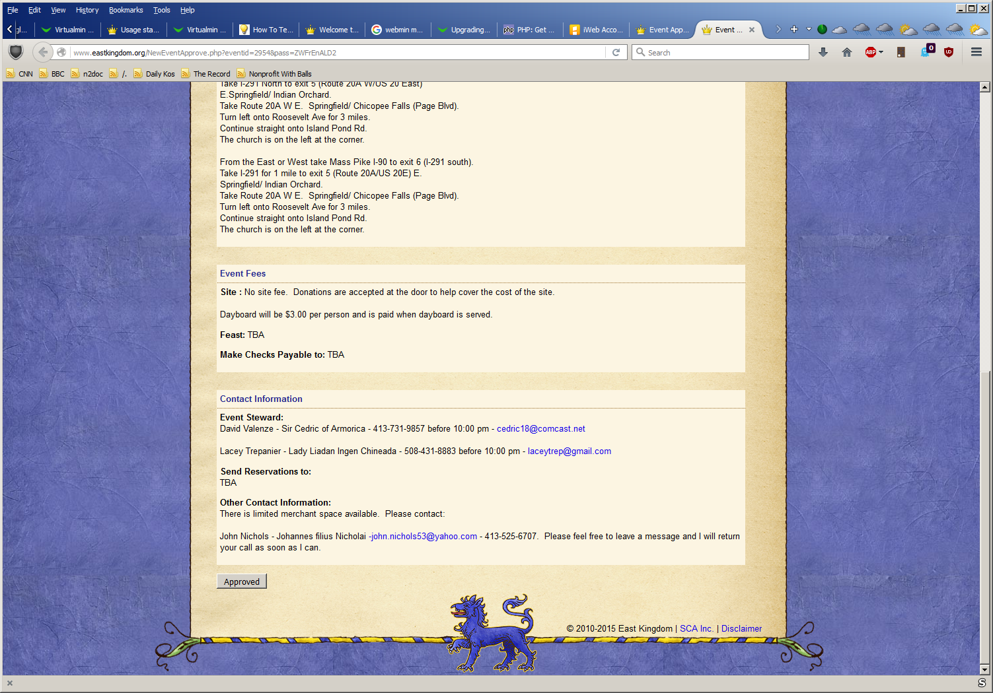
By looking over this page to verify that it is a legitimate event posting, and then clicking on the “Approved” button, your Seneschal immediately makes the event posting appear on the Kingdom Calendar:
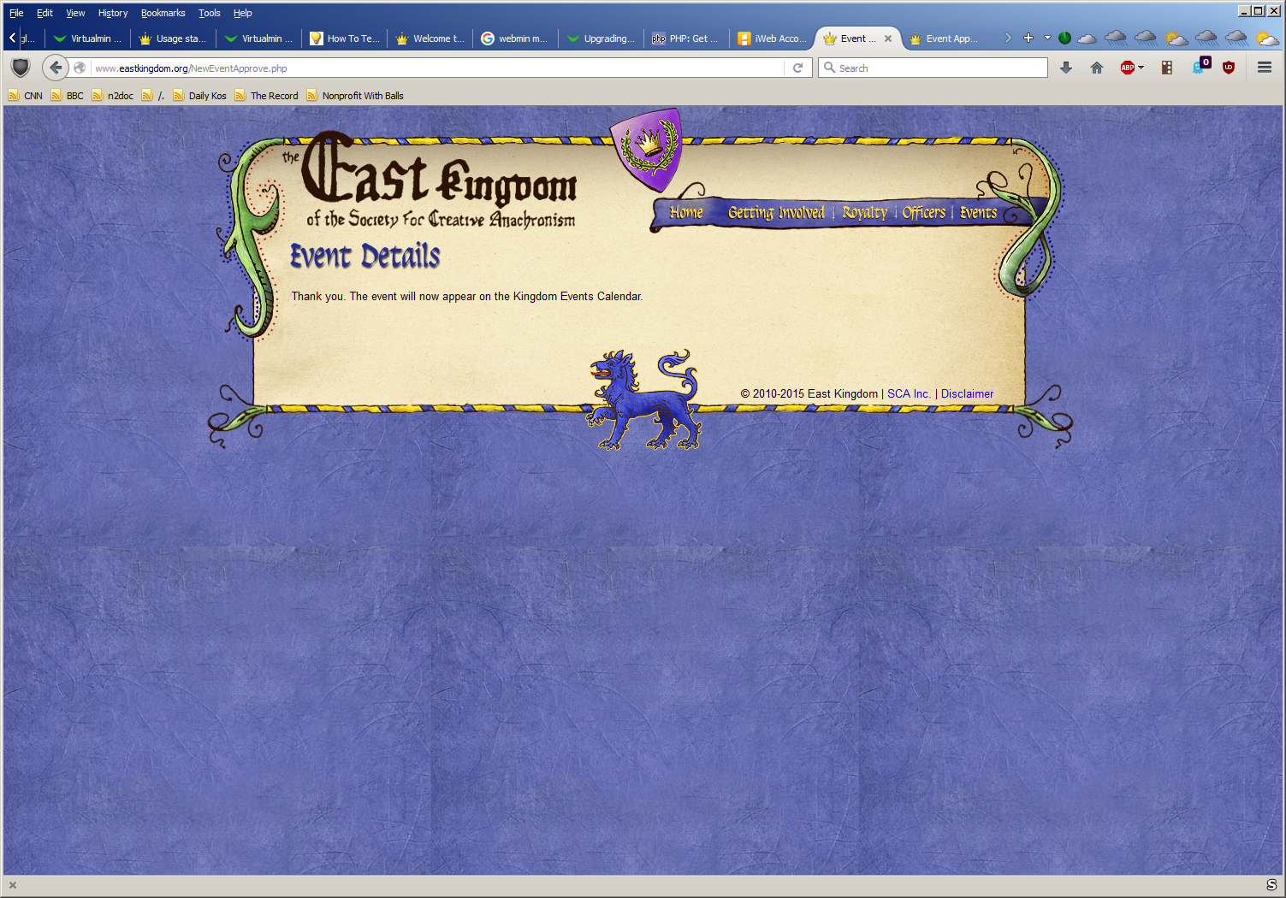

There is no longer any need to wait for the involvement of anyone at Kingdom to make an event appear, the power lies entirely in the hands of people who have a vested interest in the success of your event.
If you have problems
If for some reason this does not work, please do not wait until the last second to contact the calendar team. Getting your event listing on to the public calendar is important to the success of your event, so it really needs to happen well in advance. Submit the initial posting, give your Seneschal a reasonable amount of time to get to their email, then talk to them personally to see if they’ve gotten to it. If it appears that the process truly has not worked – either they did not receive that initial email, or the link or Approve button did not work, please email calendar@eastkingdom.org as soon as reasonably possible. We can’t fix problems that we do not know about.

